**Homework two and study guide 2021. Please turn in questions, 2, 3 and 5 for homework.**

1. a. State Kettelwell’s hypothesis.

b. Give one example of the following types of evidence used by Kettlewell to support his hypothesis

Frequency distributions (correlations),

Mark-recapture work,

Experiments on predation,

Modeling.

Comparative work on other species

1. **Calculate the relative finesses for typical and melanistic moths in Birmingham, England if the number of moths released was 500 melanistic and 400 typical non-melanistic. They recaptured 250 of the melanistic moth marked and 100 of the typical or non-melanistic.**

**3. Testing yourself on correlation:**

**a. Can you describe the correlation implied by this graph?**

**b. What can you learn from looking at outlying points? Hint: Draw one line that goes through most of the filled points and one that goes through most of the unfilled points. This will help you identify outliers.**

. 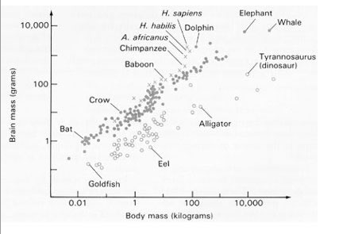

4. More recent examples of natural selection in action. Which of examples do you feel are the best examples of natural selection? Justify your answers.

**Genetic drift**

5. What are the differences between founder effects and bottlenecks?

6. Run the simulation 5 times until only one Eve remains. What is the smallest number of generations it took to fix mitochondrial type? What was the longest number of generations it took to fix mitochondrial type?

7. a. What factors explain the difference in the effects of genetic drift on gene frequencies in the three simulation graphs found on the guide?

8. Examples of genetic drift

a. What are the problem facing Florida panthers?

b. What is the role of genetic drift in creating the problem facing Tasmanian devils?

c. How is sexual selection helping to combat the problems in variation caused by a bottleneck in cheetahs?

9. Determine whether natural selection or genetic drift is driving evolution in the following case. Defend your answer.

a. Case three: bacteria. Over 11 years researchers monitored 24,000 generations of *E.coli.* All 12 of Lenski's cultures experience the same stresses, a daily boom and bust cycle, in which the bacteria are transferred to fresh glucose medium every 24 hours, than undergo 6 hours or so of plenty followed by 18 hours of starvation. All 12 lines have adapted to this regime; they grow about 60% faster than the original lines and are about 2x the size of the original lines. At the genomic level however, there are no similarities. The sequence changes found in different lines were different and had accumulated at different rates leading to conspicuous and significant discrepancies between genomic evolution and its visible effects.